**UNIT 4: LEARNING WITH TREES**

1. Explain with an example the steps involved in Iterative Dichotomiser 3(ID3) Algorithm.
2. Write and explain the steps involved in Classification and Regression Trees (CART).
3. What are the similarities and differences between ID3 and CART?

**UNIT 4: PROBABILISTIC LEARNING**

1. List and briefly explain a few applications of the Expectation Maximisation Algorithm.
2. What are the two distinctive steps of the Expectation Maximisation Algorithm? Briefly explain how it this algorithm fits into the Gaussian Mixture Model(GMM).
3. What is the difference between K-means Clustering and GMM? Why do we need GMM?
4. With any example of your choice illustrate the use of k-Nearest Neighbour(KNN) as a probabilistic learning algorithm.
5. All numericals to solve KNN is the slide ‘Probabilistic Learning_KNN.pdf’

**UNIT 4: SUPPORT VECTOR MACHINES (SVM)**

1. Numericals for Linearly Separable and Non-Linearly separable data in the slides ‘Support Vector Machines_MKN.pdf’ and ‘SVM.example_PB.pdf’
2. Explain how extensions of SVM is applied to ***any one*** of the below scenarios:

**(i)** Multi-class classification

**(ii)** Regression

1. Suppose that the following are a set of points in two classes:

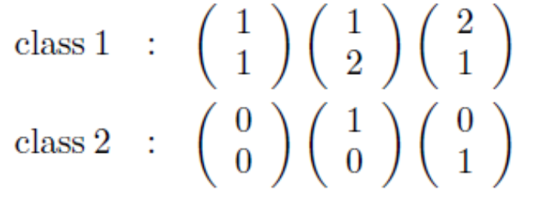

Plot them and find the optimal separating line. What are the support vectors, and what is the margin?

1. Suppose that the following are the given positively labeled data points in ℝ2:

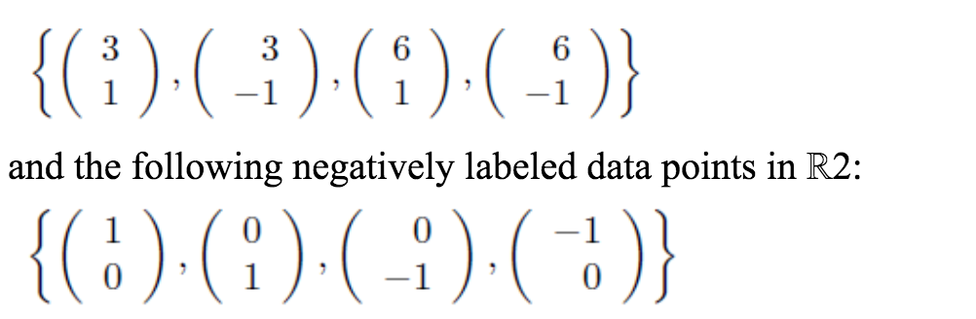

Obtain a separating hyperplane that accurately discriminates the two classes using SVM.

1. Suppose that the points are now:

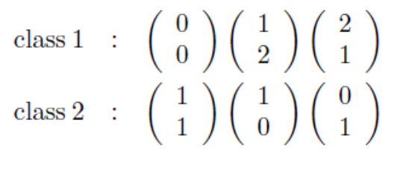

Try out the different basis functions that were given in the chapter to see which separate this data and which do not.